4.2.1 Library facilities in CIs/ OCC

Websites of Libraries of CIs/OCC
BARC: http://www.barc.gov.in/kmg/sird/sirdfacdig.html
URL of the IMSc Library catalog :https://library.imsc.res.in
URL of HRI Web based Integrated Library Management System :http://www.hri.res.in/~libweb
URL of NISER Library: https://www.niser.ac.in/library/
RRCAT: http://rrcat.gov.in/library/index.html
IoP: https://www.iopb.res.in/~library/
IPR: http://www.ipr.res.in/library/
TMC:https://tmc.gov.in/digital-library/
SINP: http://www.saha.ac.in/web/library-home

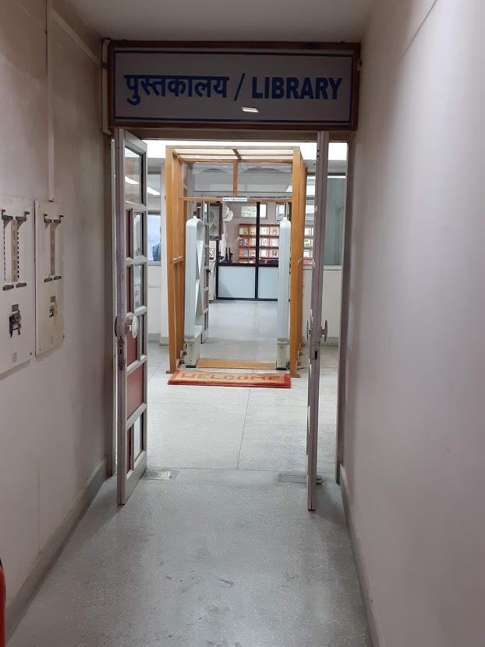
HRI

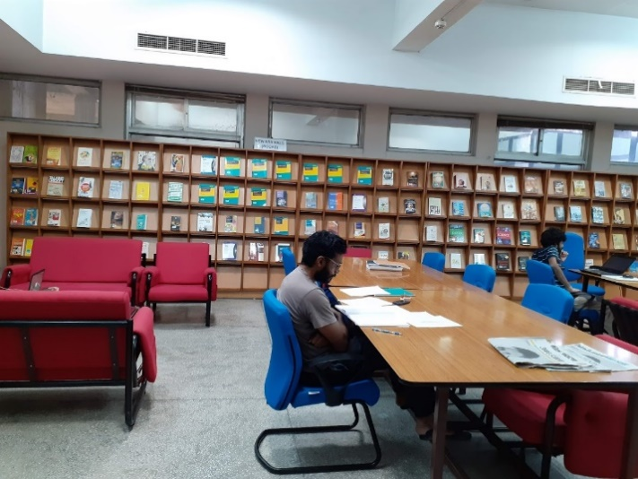

Reading room

HRI: BACK Volumes
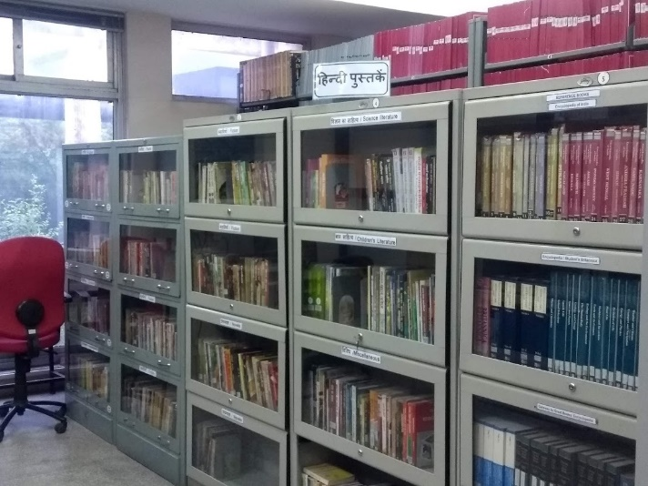

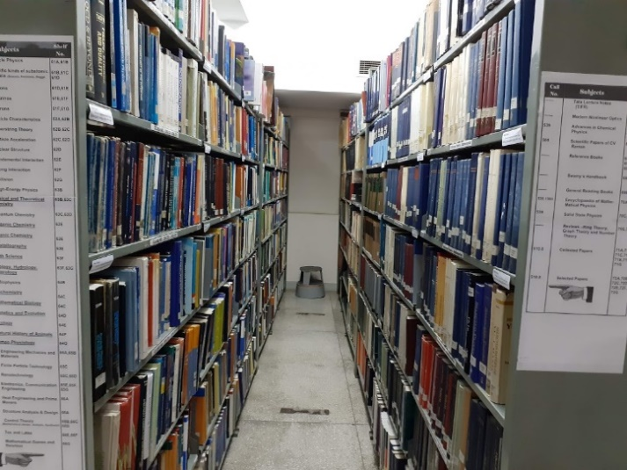

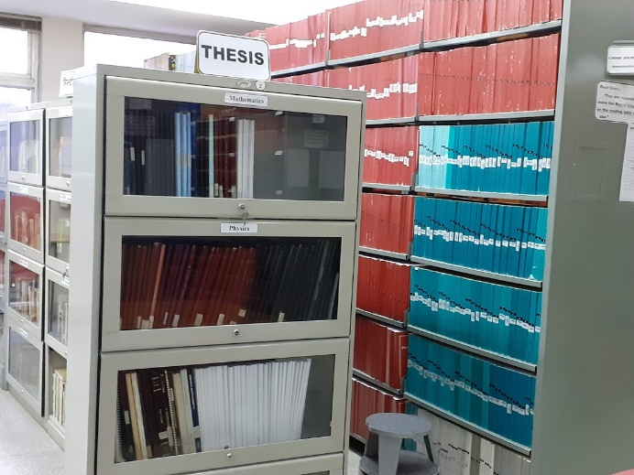
TEXT books sections
